**Pseudocode: Password Validation**

1. **Input** password
2. Set contains_number to False
3. **FOR** each character in password
   * **IF** character is a number **THEN**
     + Set contains_number to True
   * **ENDIF** **ENDFOR**
4. **IF** password length > 8 **AND** contains_number = True **THEN**
   * Display "Password is valid" **ELSE**
   * Display "Password is invalid" **ENDIF**

<https://www.codecademy.com/article/pseudocode-and-flowcharts>

**To check greatest of three numbers**

Step1: Start

Step2: Get A, B, C

Step3: if(A>B) goto Step4 else goto step5

Step4: If(A>C) print A else print C

Step5: If(B>C) print B else print C

Step6: Stop

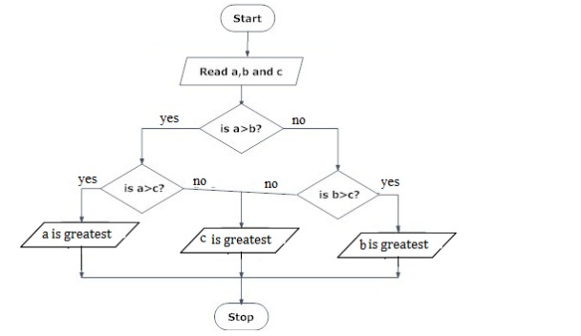

BEGIN

READ a, b, c

IF (a>b) THEN

IF(a>c) THEN

DISPLAY a is greater

ELSE

DISPLAY c is greater

END IF

ELSE

IF(b>c) THEN

DISPLAY b is greater

ELSE

DISPLAY c is greater

END IF

END IF

END

**Write an algorithm to print n odd numbers**

Step 1: start

step 2: get n value

step 3: set initial value i=1

step 4: check if(i<=n) goto step 5 else goto step 8

step 5: print i value

step 6: increment i value by 2

step 7: goto step 4

step 8: stop

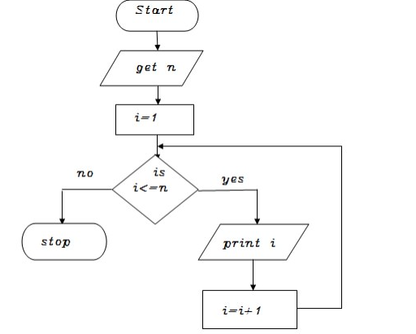

BEGIN

GET n

INITIALIZE i=1

WHILE(i<=n) DO

           PRINT i

           i=i+2

ENDWHILE

END

**Write an algorithm to print to print cubes of a number**

Step 1: start

step 2: get n value

step 3: set initial value i=1

step 4: check i value if(i<=n) goto step 5 else goto step8

step 5: print i*i *i value

step 6: increment i value by 1

step 7: goto step 4

step 8: stop

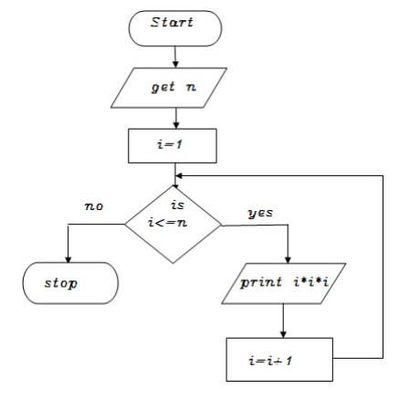

BEGIN

GET n

INITIALIZE i=1

WHILE(i<=n) DO

           PRINT i*i*i

           i=i+2

ENDWHILE

END

**Write an algorithm to find factorial of a given number**

Step 1: start

step 2: get n value

step 3: set initial value i=1, fact=1

Step 4: check i value if(i<=n) goto step 5 else goto step8

step 5: calculate fact=fact*i

step 6: increment i value by 1

step 7: goto step 4

step 8: print fact value

step 9: stop

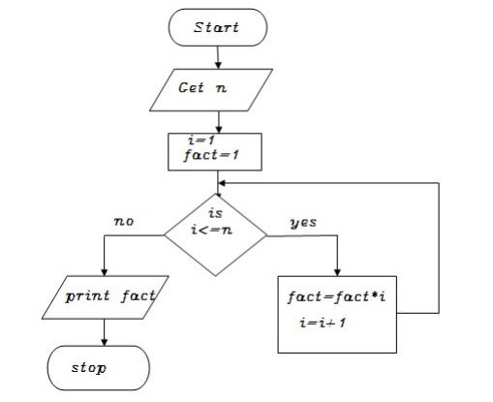

BEGIN

GET n

INITIALIZE i=1,fact=1

WHILE(i<=n) DO

           fact=fact*i

           i=i+1

ENDWHILE

PRINT fact

END